How to Use the TakeALot.com Wish List

Step 1:
To visit our Wish List please visit the link by typing it directly into your web browser: https://www.takealot.com/wishlist/8629327/detail/1

Step 2:
Find items you would like to purchase and click on ‘Add to Cart.” When you’re ready, click on the cart and choose Checkout. If you are new to TakeAlot.com, you will need to create an account.

Step 3:
Choose Delivery and add our address. Please enter it exactly as it is shown below so our local courier knows where to go.
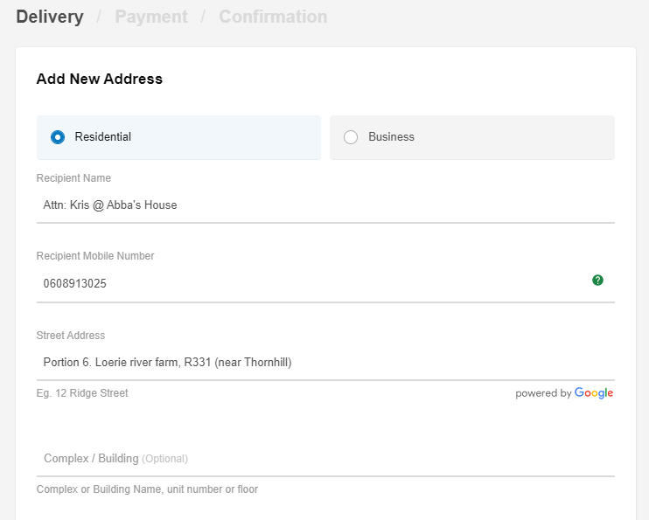

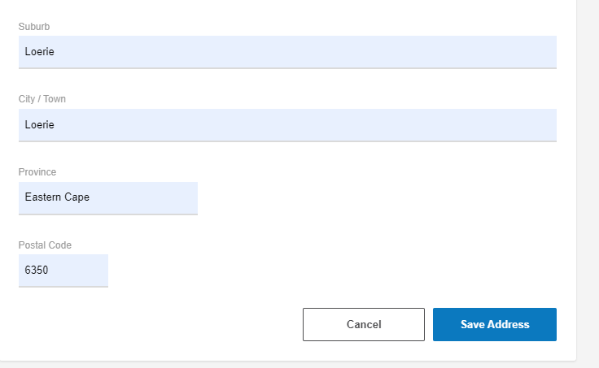

Step 4:
Enter your payment information. Receive your confirmation information. If you’d like for us to know there’s a package coming our way, please feel free to email us your confirmation information to: abbashousesa@gmail.com

